Task No 01: Create a program to check whether the No is even or odd.

Input:

using System;

namespace Abdullah_Sadiq_Cp_Lab_05

{

class Program

{

static void Main(string[] args)

{

int num;

string result;

Console.WriteLine("Enter Number:");

num = Convert.ToInt32(Console.ReadLine());

Console.Write(num);

result = (num % 2 == 0) ? (" is an Even Number") : (" is an Odd Number");

Console.WriteLine(result);

}

}

}

Output:

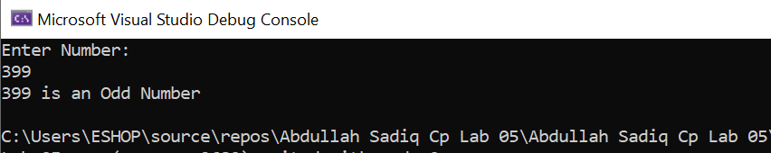

Task No 02: Create a simple calculator using if else condition in which you will take two number as input and ask user which operation he/she wants to perform.

Input:

using System;

namespace Abdullah_Sadiq_Cp_Lab_05

{

class Program

{

static void Main(string[] args)

{

char operation;

int num1, num2, result;

Console.WriteLine("Enter First Number:");

num1 = Convert.ToInt32(Console.ReadLine());

Console.WriteLine("Enter Second Number:");

num2 = Convert.ToInt32(Console.ReadLine());

Console.WriteLine("Enter Operation (+,-,*,/)");

operation = Convert.ToChar(Console.ReadLine());

switch (operation)

{

case '+':

result = num1 + num2;

Console.WriteLine("After adding {0} and {1}, result is {2}", num1,num2,result);

break;

case '-':

result = num1 - num2;

Console.WriteLine("After Substracting {0} from {1}, result is {2}", num2, num1, result);

break;

case '*':

result = num1 * num2;

Console.WriteLine("After Multiplying {0} and {1}, result is {2}", num1, num2, result);

break;

case '/':

if (num2 == 0)

{

Console.WriteLine("Math Error");

}

else

{

result = num1 / num2;

Console.WriteLine("After Dividing {0} into {1}, result is {2}", num1, num2, result);

}

break;

default:

Console.WriteLine("Invalid Operation!");

break;

}

}

}

}

Output:

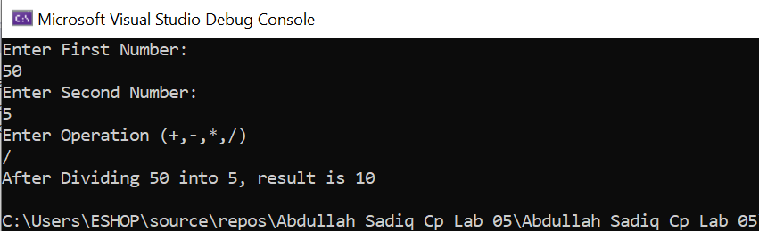

Task No 03: Write a Program using nested ifs in which the user is asked to do the following:

1. Confirm if user wants to play the game “Guess the secret number”
2. If false, then print message “Maybe next time”; if true, then ask “Enter your age”
3. If age is less than 5 then print “You are too young to play”, else ask “Enter any number”.
4. If number is equal to the secret number then print “You have successfully guessed the secret number; else print “You were not successful in guessing the secret number”.

**Note:** You have to store a secret number in a variable in order to compare it.

Input:

using System;

namespace Abdullah_Sadiq_Cp_Lab_05

{

class Program

{

static void Main(string[] args)

{

int secretNumber = 3123;

int secretNumberIn;

Console.WriteLine("Do you want to play a Game, Yes or No ?");

string opt = Console.ReadLine();

if (opt == "Yes" || opt == "No")

{

Console.WriteLine("Enter Your Age:");

int age = Convert.ToInt32(Console.ReadLine());

if (age > 5)

{

Console.WriteLine("Guess the Secret Number!");

secretNumberIn = Convert.ToInt32(Console.ReadLine());

if (secretNumber == secretNumberIn)

{

Console.WriteLine("Congratulations! You have successfully guessed the secret number");

}

else

{

Console.WriteLine("Sorry, You were not successful in guessing the secret Number");

}

}

else

{

Console.WriteLine("Too Young to Play!");

}

}

else

{

Console.WriteLine("Ok sure, Have a Nice Day");

}

}

}

}

Output:

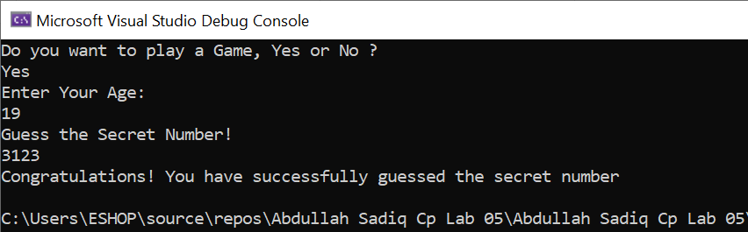

Task No 04: Create a simple application which will check the vowel using switch case.

Input:

using System;

namespace Abdullah_Sadiq_Cp_Lab_05

{

class Program

{

static void Main(string[] args)

{

string v;

Console.WriteLine("Enter an Alphabet:");

v = Console.ReadLine();

switch (v)

{

case "a":

Console.WriteLine("{0} is a Vovel.",v);

break;

case "e":

Console.WriteLine("{0} is a Vovel.", v);

break;

case "i":

Console.WriteLine("{0} is a Vovel.", v);

break;

case "o":

Console.WriteLine("{0} is a Vovel.", v);

break;

case "u":

Console.WriteLine("{0} is a Vovel.", v);

break;

default:

Console.WriteLine("{0} is a Consonant.", v);

break;

}

}

}

}

Output:

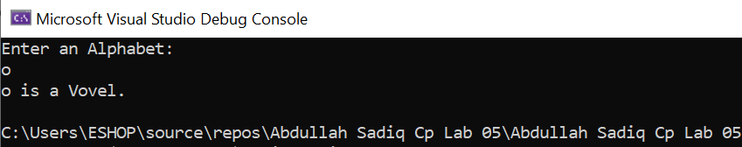

Task No 05: Create a simple program for Bahria Check in system.

Input:

using System;

namespace Abdullah_Sadiq_Cp_Lab_05

{

class Program

{

static void Main(string[] args)

{

string campus = "BUKC";

string campusIn;

Console.WriteLine("\t-Student Data Check for Entry-");

Console.WriteLine("-Are you from Bahria University?");

Console.WriteLine("\tPress Y for Yes, N for No");

string opt = Console.ReadLine();

if (opt == "Y")

{

Console.WriteLine("-From which Campus?");

campusIn = Console.ReadLine();

if (campus == campusIn)

{

Console.WriteLine("You are allow to Enter, have a Nice Day");

}

else

{

Console.WriteLine("Sorry you are not allow to Enter BUKC");

}

}

else

{

Console.WriteLine("Sorry You are not allow to enter Bahria University");

}

}

}

}

Output:

